Different Date Formats

DD-MM-YYYY

24-12-2021

MM-DD-YYYY

DD\MM\YYYY

24\12\2021

DD\MM\YY

24\12\21

Through Wizard we can load only load files that are less than 50 MB in size

**Regular Data flow in Snowflake projects**

**Amazon AWS(Amazon Web Services) AWS S3**

**Microsoft Azure Azure Blob storage/ADLS (Azure data lake service)**

**Google GCP (Google cloud platform)**

**Oracle/SQL Server/MySQL/MongoDB/Applications 🡪 AWS S3 (Datalake) – raw (Taken care by Different Team) --- generate data in CSV files**

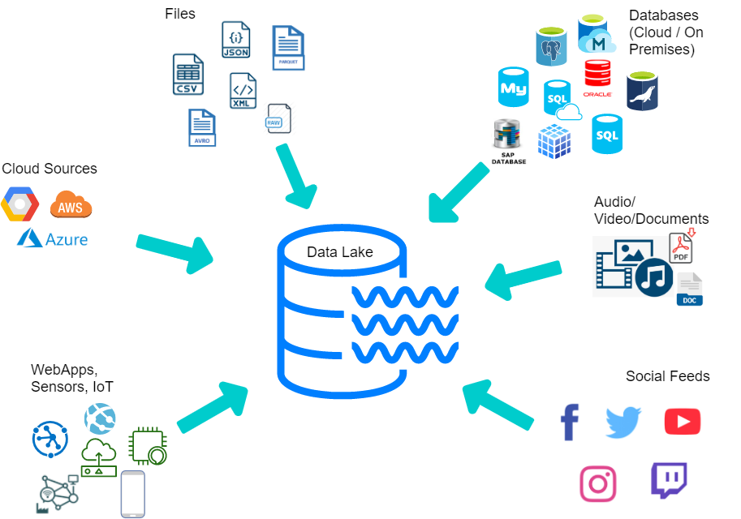

Data Lake is a system or **repository** of data stored in its **natural/raw format** either in **structured, semi structured or unstructured** format

Cloud Data Lake is a **cloud-hosted centralized repository** that allows you to store all your structured, semi structured and unstructured data at any scale, typically using an **object store** such as Amazon S3 or Microsoft Azure Data Lake Storage (ADLS), BLOB STORAGE or Google cloud storage

Structured files: Delimited files, CSV (comma separated values), TSV (Tab separated value)..

Semi structured files: JSON, XML, PARQUET, ORC, AVRO..

Unstructured files: Audio files, video files, PDF, Excel, word documents, Images…

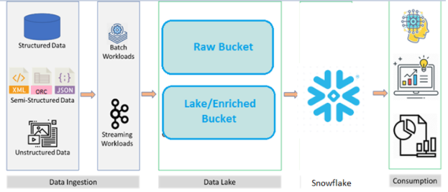

**S3->External stage -> copy commands -> Snowflake (Snowflake Developer/Lead’s responsibility)**

**Local drives/servers -> load files to Snowflake Internal stage/User or table stage using PUT command -> copy commands to load data into Snowflake tables**

**Location of data files where data can be loaded from is called stage**

**AWS=> AWS S3 (storage)**

**Azure => Azure Blob storage (storage) or Azure Data Lake storage(ADLS )**

**Google cloud=> Google cloud storage (storage)**